**Assignment: Windows Functions**

1. Rank the customers based on the total amount they've spent on rentals.

select c.customer_id,concat(c.first_name,' ',c.last_name) as customer_name,sum(p.amount) as Total_Amount_Spent,

rank() over(order by sum(p.amount) desc) as Customer_Rank from customer c join payment p on c.customer_id = p.customer_id

group by c.customer_id order by Total_Amount_Spent desc;

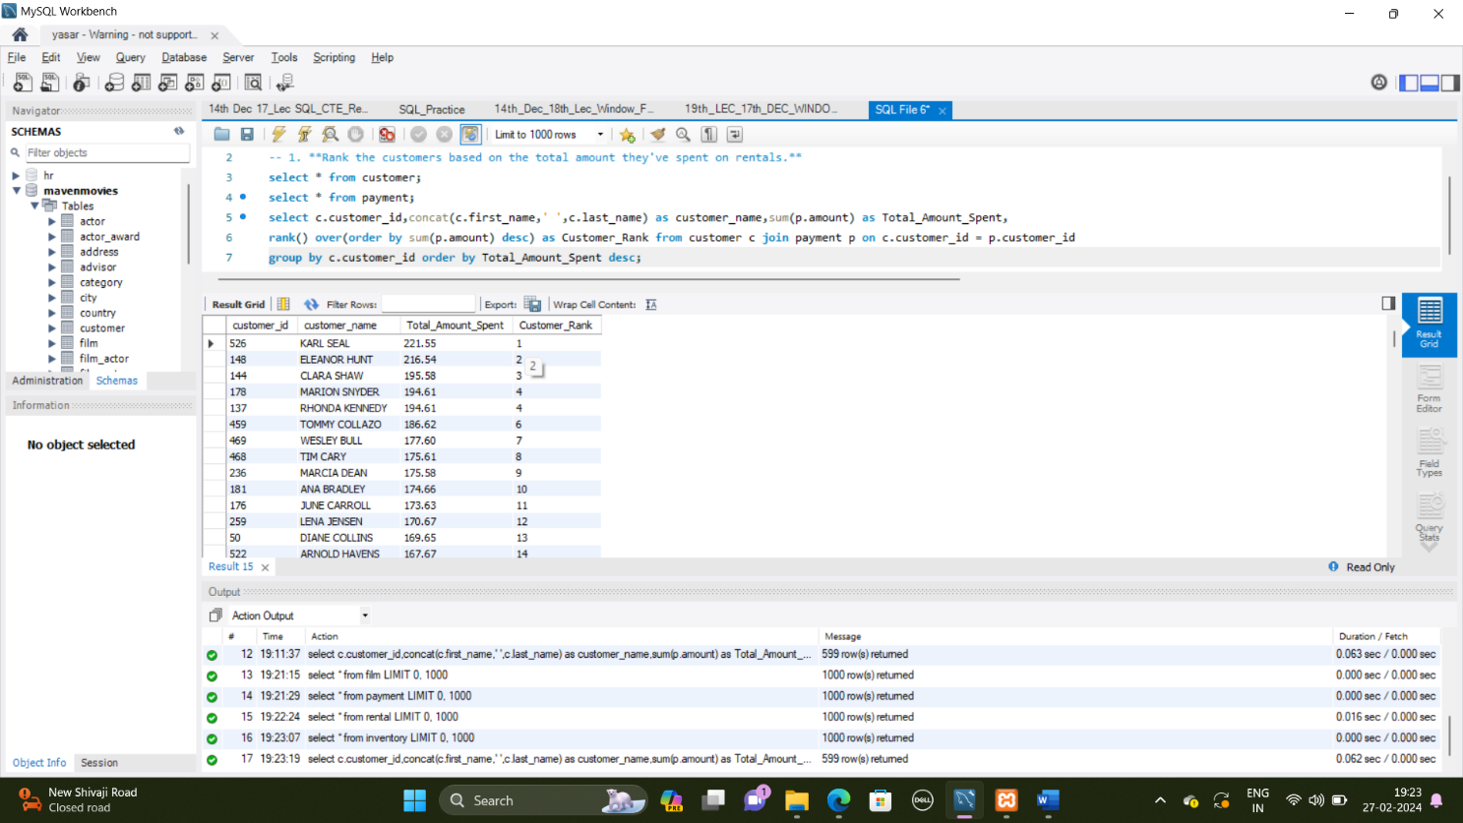

1. Calculate the cumulative revenue generated by each film over time.

select f.film_id,f.title as Title,sum(p.amount) over(partition by f.film_id order by p.payment_date) as cumulative_revenue from film f

join inventory i on f.film_id = i.film_id join rental r on i.inventory_id = r.inventory_id join payment p on r.rental_id = p.rental_id

order by f.film_id,p.payment_date;

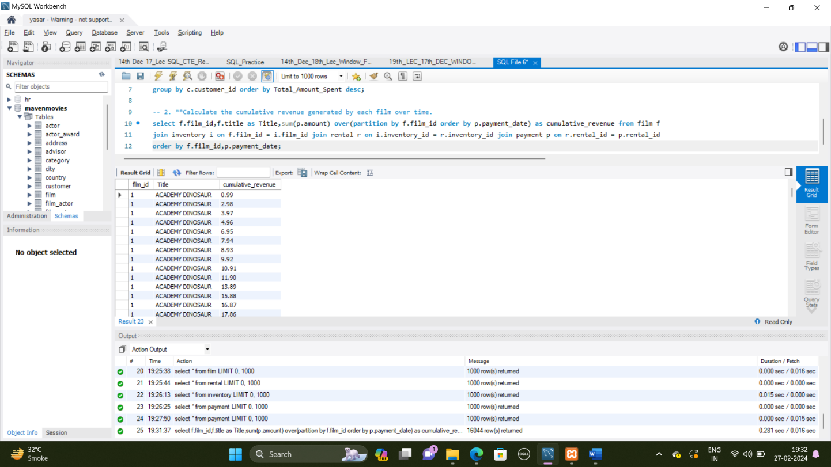

1. Determine the average rental duration for each film, considering films with similar lengths.

select f.film_id,f.title as Title,f.rental_duration as Rental_Duration,avg(f.rental_duration) over(order by f.rental_duration) as avg_Rental_Duration

from film f order by f.film_id;

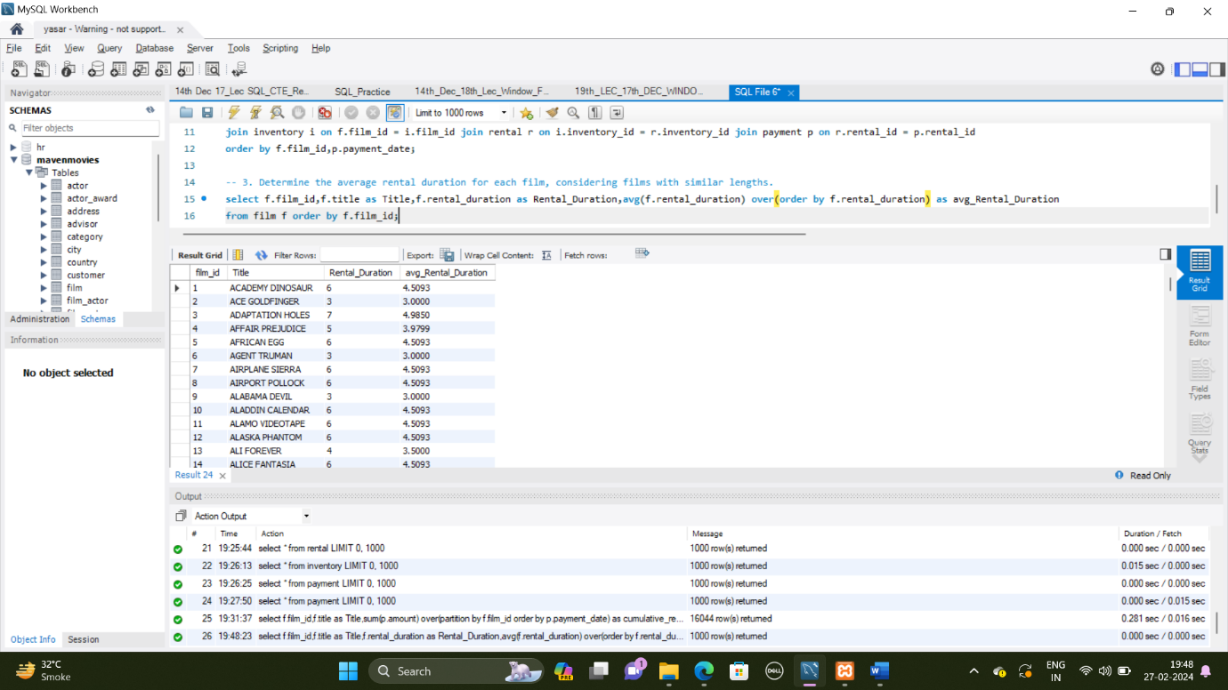

1. Identify the top 3 films in each category based on their rental counts

with ranked_films as (

select f.film_id, f.title, c.name as Category, count(rental_id) as rental_count,

row_number() over (partition by c.name order by count(rental_id) desc) as Category_Rank

from film f join film_category fc on f.film_id = fc.film_id

join category c on fc.category_id = c.category_id

join inventory i on f.film_id = i.film_id

join rental r on i.inventory_id = r.inventory_id

group by f.film_id,f.title,c.name)

select film_id,title,category,rental_count from ranked_films where Category_Rank <= 3 order by category,Category_Rank;

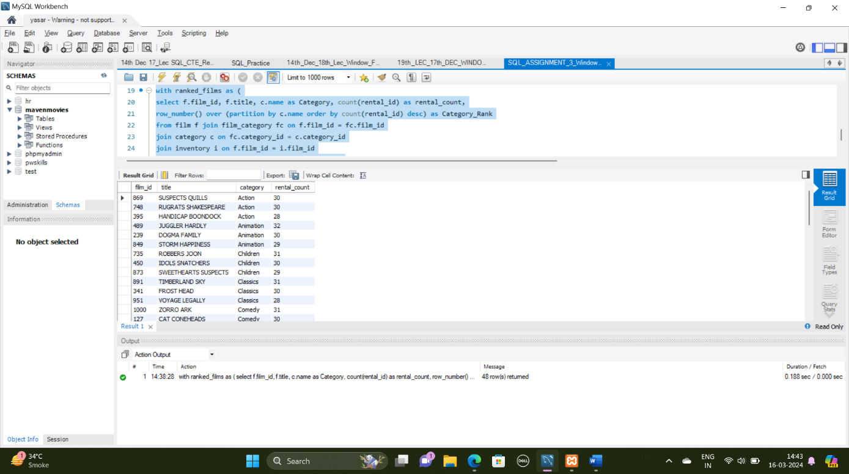

1. Calculate the difference in rental counts between each customer's total rentals and the average rentals across all customers.

with customer_rentals as (

select c.customer_id, count(rental_id) as total_rentals, avg(count(rental_id)) over () as avg_rental_all_customers from customer c

left join rental r on c.customer_id = r.customer_id group by customer_id)

select customer_id, total_rentals, avg_rental_all_customers, total_rentals - avg_rental_all_customers as rental_count_diff from customer_rentals;

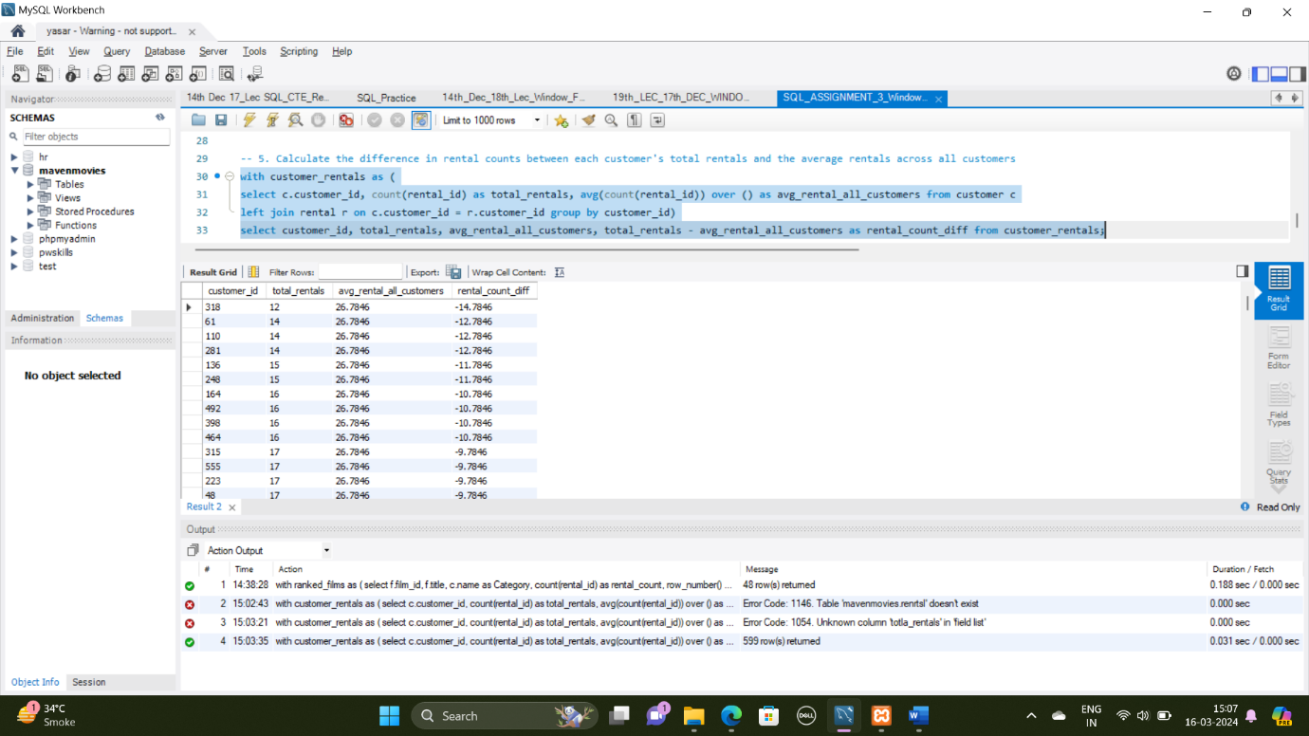

1. Find the monthly revenue trend for the entire rental store over time.

with monthly_revenue as (

select date_format(r.rental_date, '%Y-%M') as rental_month,

sum(p.amount) as monthly_revenue, row_number() over (order by date_format(r.rental_date, '%Y-%M')) as month_rank from rental r

join payment p on r.rental_id = p.rental_id group by date_format(r.rental_date, '%Y-%M') )

select rental_month, monthly_revenue, lag(monthly_revenue) over (order by month_rank) as previous_month_revenue

from monthly_revenue order by rental_month;

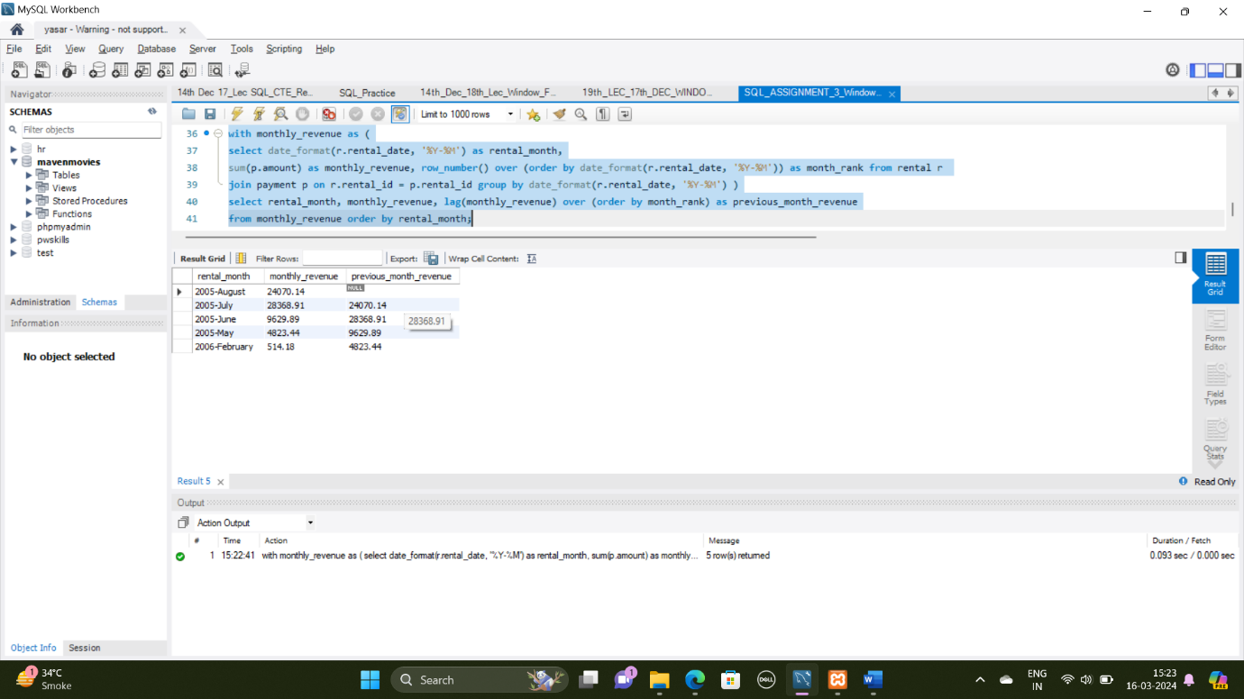

1. Identify the customers whose total spending on rentals falls within the top 20% of all customers.

with customer_spending as (

select c.customer_id, sum(p.amount) as total_spending, percent_rank() over (order by sum(p.amount) desc) as spending_percentile from customer c

left join payment p on c.customer_id = p.customer_id group by customer_id)

select customer_id, total_spending from customer_spending where spending_percentile >= 0.8;

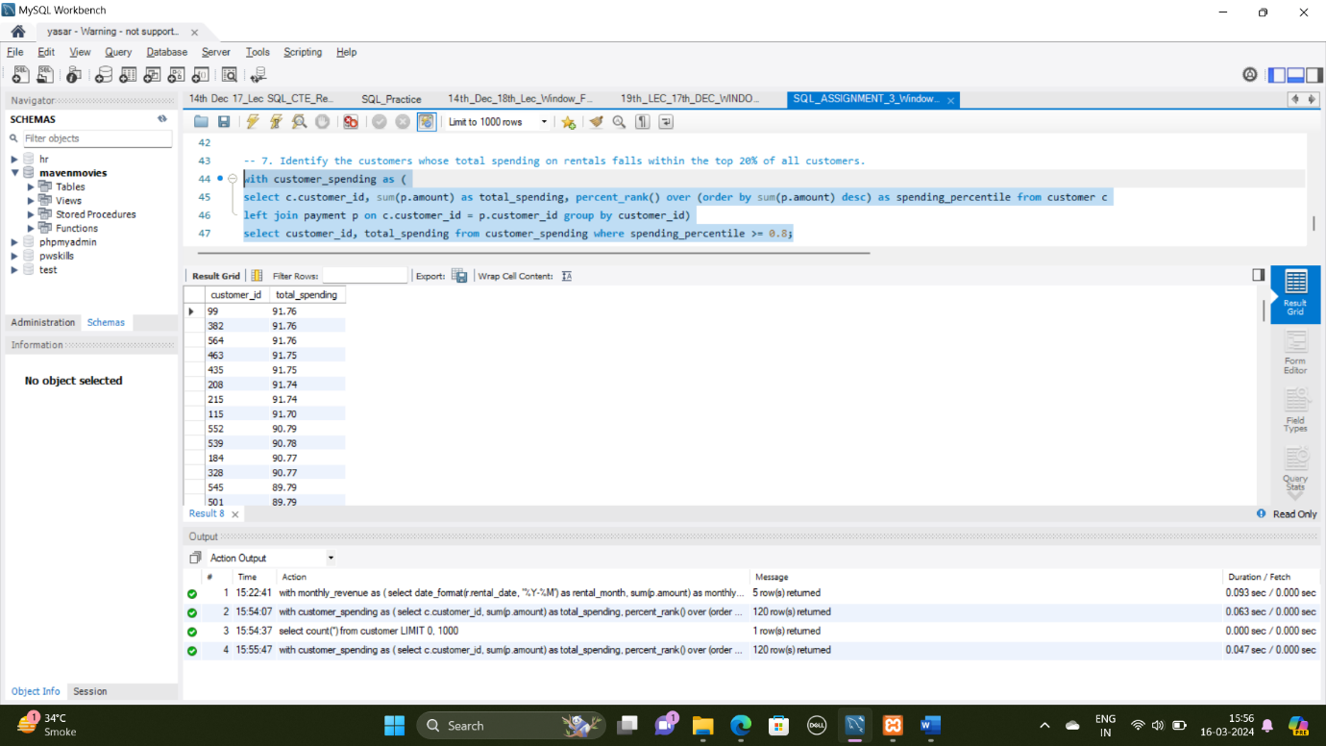

1. Calculate the running total of rentals per category, ordered by rental count.

WITH category_rentals AS (

select c.name as category, count(r.rental_id) as rental_count, row_number() over (partition by c.name order by count(r.rental_id) desc) as category_rank

from rental r join inventory i on r.inventory_id = i.inventory_id join film_category fc on i.film_id = fc.film_id

join category c on fc.category_id = c.category_id group by c.name )

select category,rental_count, sum(rental_count) over (partition by category order by category_rank) as running_total

from category_rentals order by category, category_rank;

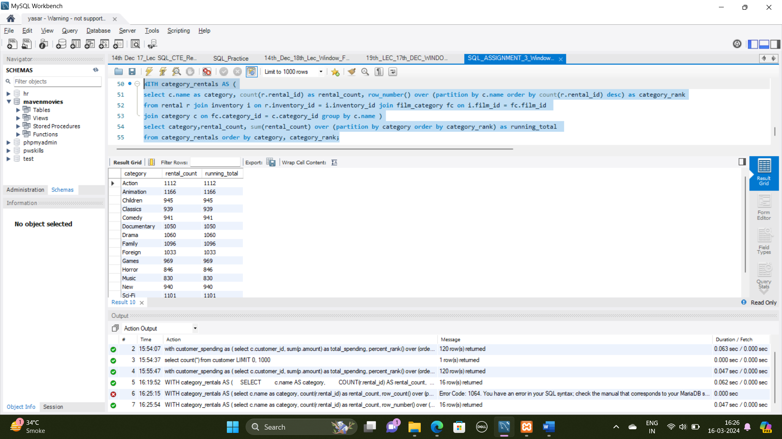

1. Find the films that have been rented less than the average rental count for their respective categories.

with category_avg_rental as (

select fc.film_id, c.name AS category, count(r.rental_id) as rental_count, avg(count(r.rental_id)) over (partition by c.name) as avg_rental_count

from rental r join inventory i on r.inventory_id = i.inventory_id

join film_category fc on i.film_id = fc.film_id

join category c on fc.category_id = c.category_id group by fc.film_id, c.name )

select f.film_id, f.title, car.category, car.rental_count, car.avg_rental_count from category_avg_rental car

join film f on car.film_id = f.film_id where car.rental_count < car.avg_rental_count;

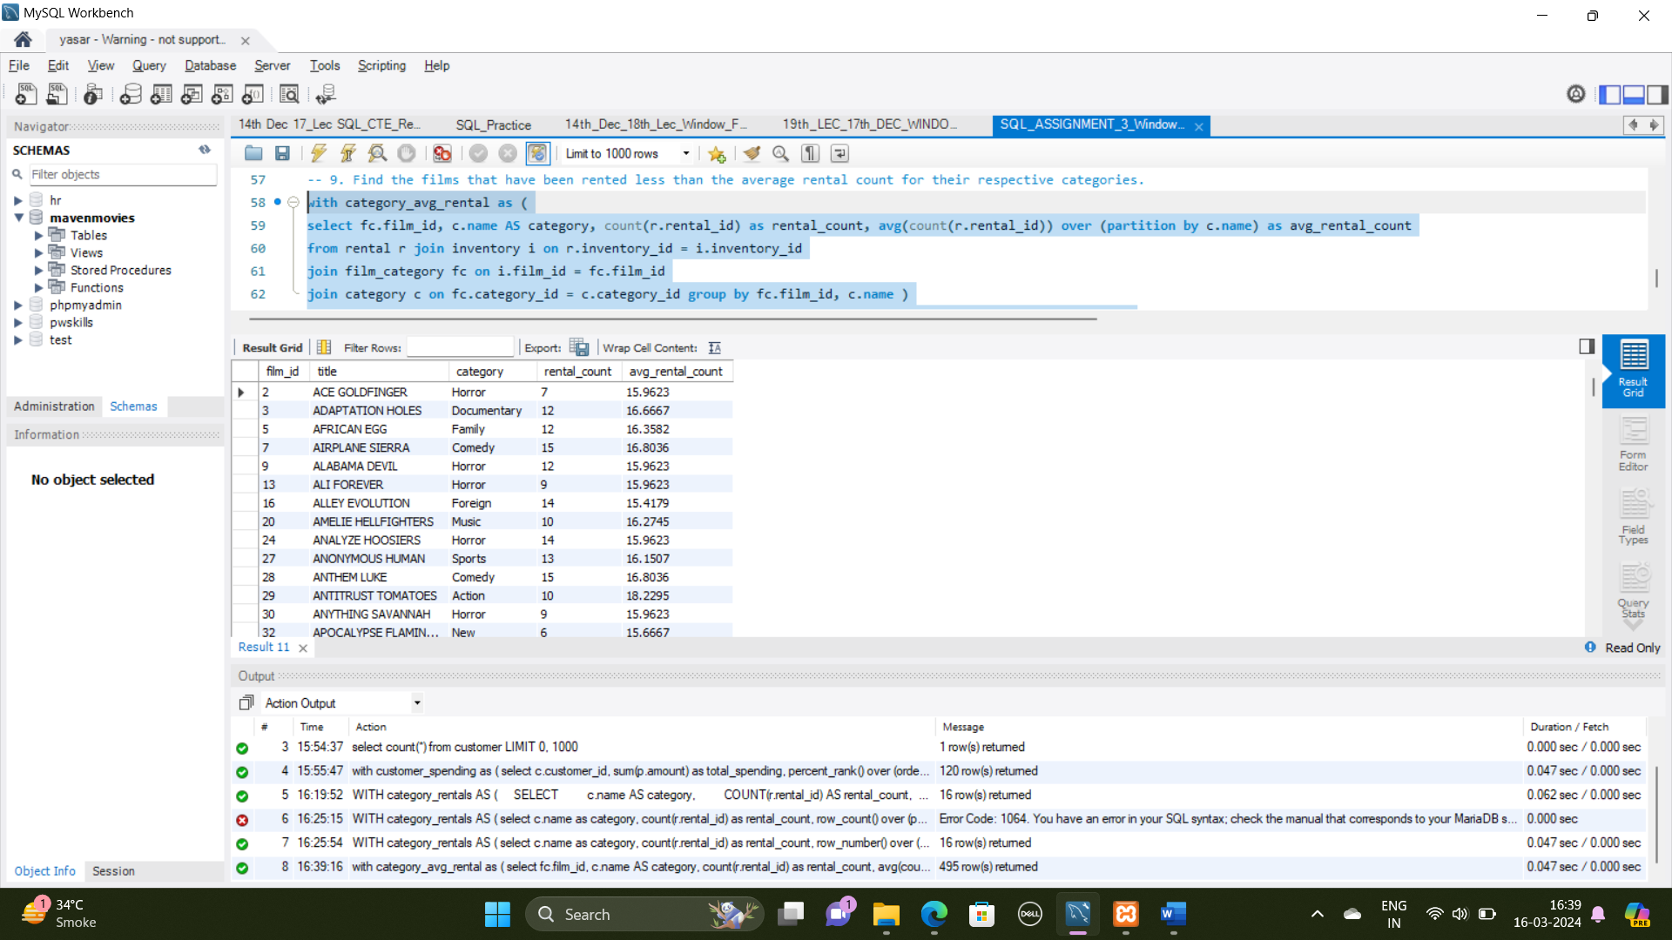

1. Identify the top 5 months with the highest revenue and display the revenue generated in each month.

WITH monthly_revenue AS (

SELECT

DATE_FORMAT(r.rental_date, '%Y-%m') AS rental_month,

SUM(p.amount) AS monthly_revenue,

ROW_NUMBER() OVER (ORDER BY SUM(p.amount) DESC) AS month_rank

FROM

rental r

JOIN

payment p ON r.rental_id = p.rental_id

GROUP BY

DATE_FORMAT(r.rental_date, '%Y-%m')

)

SELECT

rental_month,

monthly_revenue

FROM

monthly_revenue

WHERE

month_rank <= 5

ORDER BY

month_rank;

